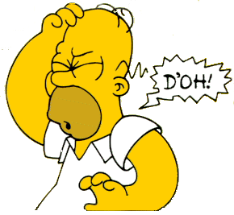
Common Event Planning Mistakes
When planning events there are so many details to keep track of and sometimes things can go wrong. Here are a few of the most common errors people make when planning events.
- Incorrect/insufficient advertising
  - Wrong, date, time, location, missing information, not enough advertising etc.
- Assumptions
  - Assuming people know what is expected of them without following up, assuming reservations/setup is taken care of
  - Failure to double check/triple check room, food, travel etc. reservations
- Insufficient allocation of funds/budget
  - Forgetting to budget for things like decorations, food, water for performers, paying extra staff/security, incidentals, additional unanticipated costs
- Procrastination
  - Not enough notice for advertising, reservations etc.
  - Waiting until the last minute for event approval, contracts, admin signatures
- Under/Overestimating audience attendance
  - Can result in insufficient space, food, cost for additional guests etc.
- Scheduling
  - Event takes longer than planned or less time than planned
  - Conflicts with other events happening simultaneously
  - Forgetting to account for setup/teardown time
- Not considering the desire of target audience
  - Event appeals to only a small number of people
  - Cost to attend event is too expensive/unrealistic
- Failure to have a backup plan
  - What happens if it rains on your outdoor concert or your comedian misses his flight?
- Not delegating/having enough help
  - Can result in burnout/stress
  - If on a team, team feels unneeded or like they can’t be trusted to help
  - If you do delegate, be sure to check in and make sure tasks are being completed

