Oregon Tech Regional Math Contest
Dear Mathematics Teacher,
It is time to register students for this year’s Oregon Tech Regional Math Contest, scheduled for Tuesday, April 17, 2017. Registration forms for each competition category are included as well as a registration summary form. All participants must be pre-registered.

As with contests in previous years, there will be competition in the following categories: First Year Algebra, Geometry, Second Year Algebra, Pre-Calculus and Calculus. Categories are open to students in grade 9 through 12 currently enrolled in the associated courses. Students may also compete if they have finished the associated course and have not taken and mathematics course above the listed category in which they compete. Ribbons will be awarded in each category and all participants will receive certificates.

The winners and perhaps the runners-up in the State Qualifying Exam for Geometry, Second Year Algebra, Pre-Calculus and Calculus will be eligible to compete in the Oregon Invitational Mathematics Tournament (OIMT) at Oregon State University this spring.

Briefly, the schedule for the day begins with check-in of pre-registered students at 8:45 a.m. in the upper lobby of the College Union outside the Mt. Mazama room. The contest starts at 9:15 a.m. with a mid-morning break for refreshments. Contest sessions should conclude around 12:00 p.m. Lunch will be provided for students and faculty. The awards ceremony is scheduled for 1:00 p.m. in the College Union Auditorium.

Please see the enclosed map for contest sites and available parking.

Calculators will be required in several sessions. Please be sure your students have them and that batteries are fresh.

All registration forms and fees of $6 /student must reach Oregon Tech by Noon, Friday, April 13, 2018. There is no registration (except substitutions) on the contest day. Phone registration will not be accepted. If you have any questions, please feel free to contact me. The Mathematics Department is looking forward to seeing you on Tuesday, April 17.

Sincerely,
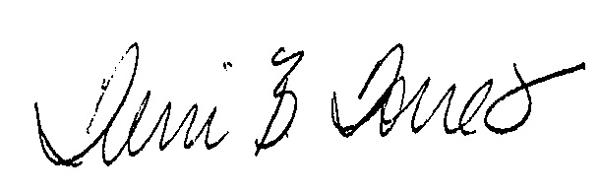

Terri B. Torres
Associate Professor of Mathematics
Oregon Institute of Technology
Klamath Falls, Oregon
541.885.1468
Terri.torres@oit.edu

