Banner 9 FAQ

Table of Contents
1. How do I log into Banner? 3
2. How do I reset my Banner password? 3
3. How do I log out of Banner 9 3
4. What are the recommended browsers for Banner 8 and Banner 9? 4
5. Can I use the browser back button to navigate in Banner 9? 4
6. Can I open Banner 9 in multiple browser tabs? 4
7. Where is the User ID and Activity Date in Banner 9 4
8. Have the date entry and displays changed for Banner 9? 4
9. How have menu options changed with Banner 9? 4
10. How have error messages and notifications changed for Banner 9? 5
11. How has moving through several sections/blocks changed from Banner 8 to Banner 9? 5
12. Where is the Supplemental Data Engine icon located in Banner 9? 5
13. Does my desktop computer need to be upgraded to support Banner 9? 5
14. How do I change my screen size in Banner 9? 6
15. What is the difference between Banner Form Mod’s and Form Customizations? 6
16. How are Mod’s Named? 6
17. How are Form and Report Customizations Named? 6
18. Still having system issues with Banner? 6
Version Control: 7

How do I log into Banner?
- Open browser, enter: https://techweb.oit.edu/ and select the Banner icon:
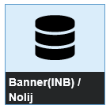
- See notes in table below for information regarding use of the different Banner links:
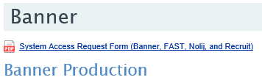  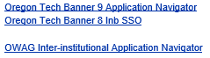 | Notes:  - Banner 9 Application Navigator is the primary Banner production link  - Banner 8 Inb SSO link can be used during Banner8/Banner 9 transition period  - OWAG link for USSE Banner users

- Log in with OIT credentials to navigate to the Banner 9 Welcome page (Application Navigator).
Note: Banner 8 and Banner 9 now use Single Sign On (SSO) to login.

How do I reset my Banner password?
There is no longer a need to reset Banner passwords because we are now using SSO to login. SSO authenticates user credentials and ensures there is an active Banner account. Please continue to open a FACTS ticket for any login or password issues.

How do I log out of Banner 9
Exit Banner 9 by selecting the lock icon from the Unified menu on the left side of the page.
Note: X’ing out of the browser may leave orphan processes open that may prevent starting a new Banner session and therefore is not the recommended approach to closing out Banner 9.

What are the recommended browsers for Banner 8 and Banner 9?
- Banner 8: Internet Explorer 11 (IE) only.
- Banner 9: Internet Explorer until after the Banner 8/Banner 9 transition period where Banner 8 forms are no longer available in Banner.
Note: Once fully transitioned to Banner 9, the only browser that will NOT work with Banner 9 is Edge. Also, in regards to Nolij users, IE is the only browser that will work with the Nolij system as it requires Java.

Can I use the browser back button to navigate in Banner 9?
DO NOT use the browser back button to navigate between Banner 9 pages. Use the Home icon to get back to the Welcome page and navigate to another page from there.

Can I open Banner 9 in multiple browser tabs?
Yes. Banner 9 can be opened in multiple tabs.

Where is the User ID and Activity Date in Banner 9
For pages, such as SPAIDEN AND PPAIDEN, that includes this information, it can be found at the bottom of the page and includes the activity date and user ID of the person who last updated the record.

Have the date entry and displays changed for Banner 9?
Yes, dates can be entered as mmddyy or mmddyyyy. Either format will display in mmddyyyy format.
To enter today’s date, type: T [TAB].

How have menu options changed with Banner 9?
Some of the menu options that were available in Banner 8 are now available in Banner 9 from “Tools” (gear icon) (Alt+Shift+T) or “Related” (relationship icon) (Alt+Shift+R). Both icons are located at the top right of the screen in the new Banner version.

How have error messages and notifications changed for Banner 9?
Warnings and errors in Banner 9 pop up in the top right corner of the screen rather than the bottom left as seen in Banner 8. Be aware that they will cover the “Start Over” and “Go” buttons until you dismiss them. To dismiss, click the number in the top right corner.
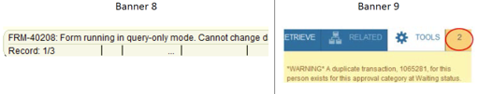

How has moving through several sections/blocks changed from Banner 8 to Banner 9?
- Banner 8: Keyboard users use Ctrl+PgDn.
- Banner 9: Keyboard users use Alt+PgDn.
- Mouse users use the following buttons:
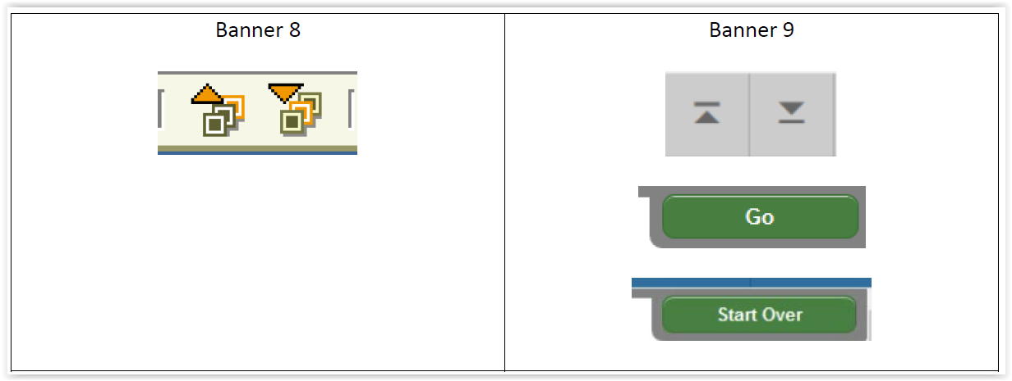
Note: “Blocks” in Banner 8 are now known as “Sections” in Banner 9

Where is the Supplemental Data Engine icon located in Banner 9?
The Supplemental Data Engine (SDE) icon that currently displays as a lightbulb on the Banner 8 toolbar now displays as “More Information” icon within sections/blocks that have been set up with SDE.
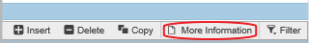

Does my desktop computer need to be upgraded to support Banner 9?
In most cases computers do not need to be upgraded. However, improvements have been seen when computers have a minimum of 8GB of RAM (memory). The Banner 9 applications run faster with more memory in the desktop equipment. It is also recommended for monitors to be at least 24 inches wide and include VGA, DVI, and HDMI ports. The resolution will provide the sharpest pictures and it is strongly recommended not to acquire a monitor with anything less than 1920 x 1080 resolution.

How do I change my screen size in Banner 9?
Windows machines support this function by holding down the Ctrl key and moving your mouse scroll wheel up and down. Another method is hold the Ctrl key and use the + and – keys.
(Note: use of “+” usually requires the shift key as well on most keyboards)

What is the difference between Banner Form Mod’s and Form Customizations?
The difference between a Banner form mod and customization is that a mod is a “modified” version of a Banner baseline form or report, while customizations do not have a baseline counterpart. It is completely OIT or USSE built.

How are Mod’s Named?
In most cases the following naming convention is followed:
- OIT created mods use the same object name as the baseline, however also includes “OIT” following the version #. For example the mod name for SOATEST is “SOATEST 8.2.OIT”.
- USSE created mods uses the same object name and adds a letter at the end of the version number. For example mod name for FAAINVE is “FAAINCE 8.9.1.2.B”

How are Form and Report Customizations Named?
In most cases the following naming convention is used:
- OIT created form customizations mods begin with a “Y” or a “Z” and includes “OIT” following the version # (ie: YFADDPR 8.1.1.OIT)
- USSE created form customizations are named as follows:
  - Finance: 1st letter is “F” followed by “W” (exception is FZIGRNT)
  - HR/Payroll: 1st letter is “P” followed by “W”
Note: Alpha char is included after the version # (ie: FWIBDSR 8.0.a)

Still having system issues with Banner?
  - Clear both your browser cache and cookies.
  - Try rebooting your system every morning. Not rebooting your system for a long period of time seems to create problems that are hard to diagnose.
  - Open a FACTS ticket providing as much information about the issue as possible.

Version Control:

Date | Description | Author | Version
9-26-18 | Initial Document | T.Sweaney | 1.00
10-15-18 | Removing non-issues:  - V1.00: #7: Cut/Paste; #13:”GYALOAD; | T.Sweaney | 1.01
1-3-19 | Finalizing document for distribution | T.Sweaney | 1.02
Note: This is a living document and will be updated as necessary.

